

**Capstone Project Report**

**Software Requirement Specification**

– Ha Noi, Sep 2023 –

# **I. Record of Changes**

| Date | A*  M, D | In charge | Change Description |
| --- | --- | --- | --- |
| 29/09/2023 | A | NGUYỄN HOÀI NAM | Add Document |
| 29/09/2023 | A | NGUYỄN HOÀI NAM | Add Context Diagram |
| 29/09/2023 | M | NGUYỄN HOÀI NAM | Add text Context Diagram |
| 30/09/2023 | A | NGUYỄN HOÀI NAM | Add User Requirements actor, Guest Feature, User Feature, student feature |
| 30/09/2023 | M | NGUYỄN HOÀI NAM | Add User Requirements actor, Guest Feature, User Feature, student feature |
| 30/09/2023 | A | ĐẶNG VIỆT ANH | Add System Functionalities, Screen Descriptions |
| 30/09/2023 | A | ĐẶNG VIỆT ANH | Add System Functionalities Screens Flow |
| 30/09/2023 | M | VŨ QUỐC BÌNH | Screen Authorization |
| 30/09/2023 | M | VŨ QUỐC BÌNH | Non-UI Functions |
| 30/09/2023 | A | VŨ QUỐC BÌNH | Entity Relationship Diagram |
| 06/10/2023 | M | NGUYỄN HOÀI NAM | Guest Feature, User Feature, student feature, admin feature, manage feature, Context Diagram |
| 24/10/2023 | M | NGUYỄN HOÀI NAM | Guest Feature, User Feature, student feature, admin feature, manage feature, Context Diagram |

*A - Added M - Modified D - Deleted

# **II. Software Requirement Specification**

## **1. Requirement Overview**

### **1.1 Context Diagram**

The IMS is a web application for managing software project issues and defects. The context diagram below shows the key external entities:

· Students log issues for assigned projects.

· Team Leads oversee project teams and issues.

· Teachers manage classes comprised of multiple teams.

· Managers configure subjects with multiple classes.

· Admins handle overall system configuration.

The IMS provides a web interface for users to track issues. Data is persisted in a database. The system integrates with GitLab for issue synchronization. Email/SMS services are leveraged for notifications.

[Context Diagram]

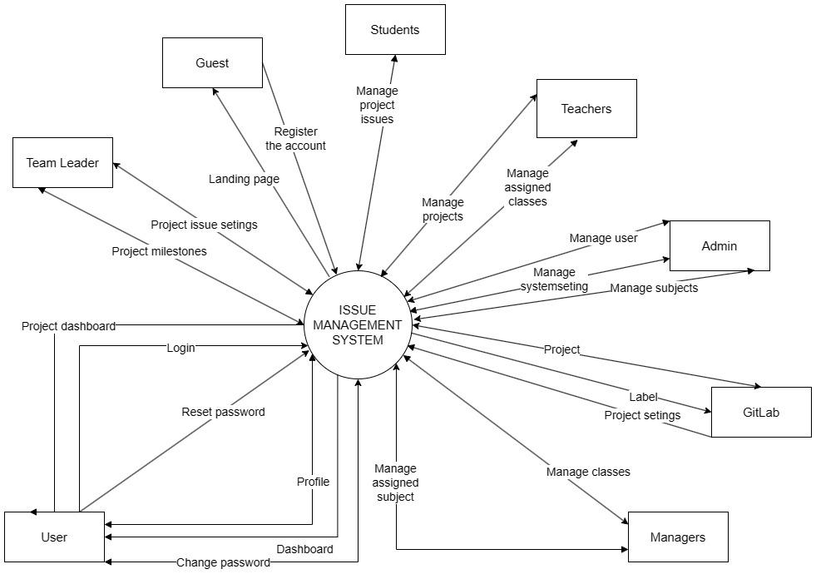

### **1.2 User Requirements**

#### **1.2.1 Actors**

| **#** | **Actor** | **Description** |
| --- | --- | --- |
| 1 | Student | Creates and manages issues for assigned projects |
| 2 | Team Lead | Oversees project teams and can update project issues |
| 3 | Teacher | Manages classes comprised of multiple project teams |
| 4 | Manager | Oversees subjects containing multiple classes |
| 5 | Admin | Handles overall system configuration and management |

#### **1.2.2 Use Cases**

##### **a. Guest Feature**

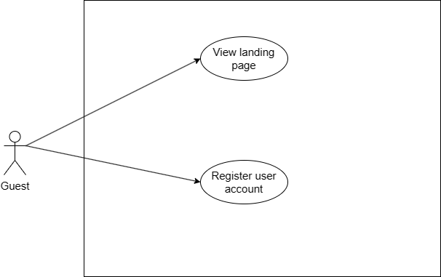

##### **b. User Feature**

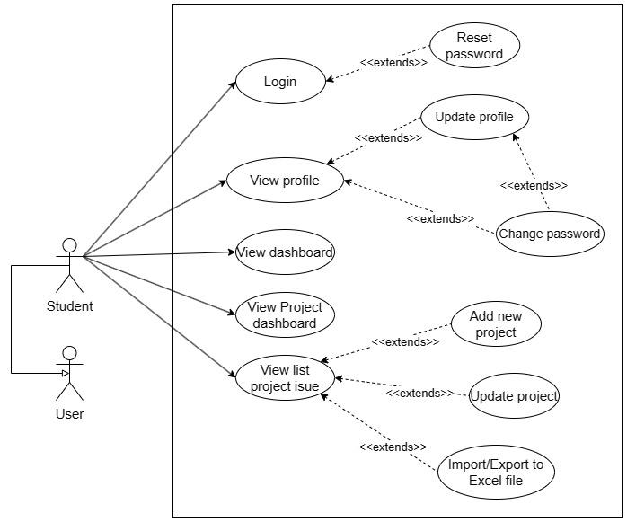

##### **c. Teacher Feature**

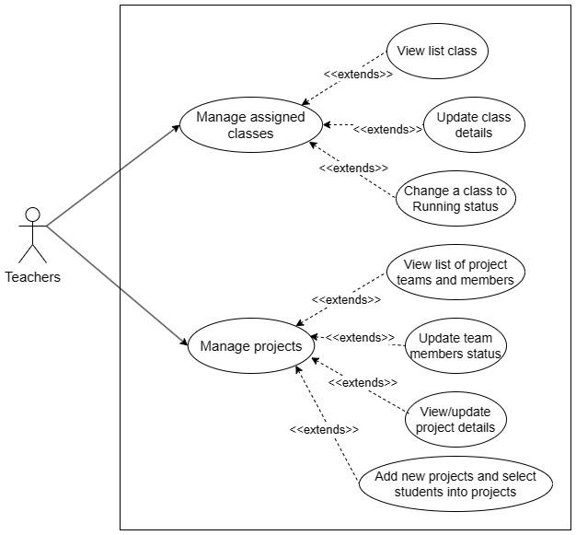

##### **d. Admin Feature**

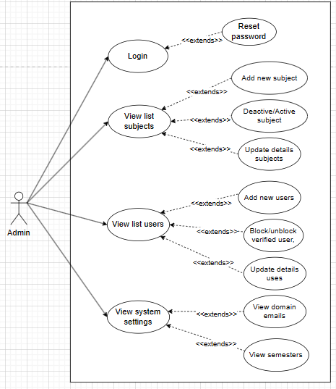

##### **e. Manage Feature**

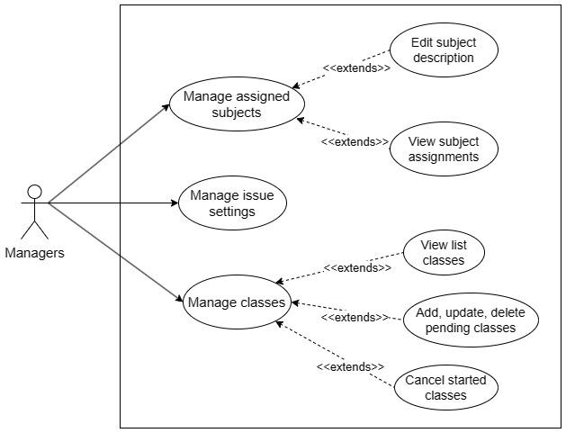

##### **f. Gitlab Feature**

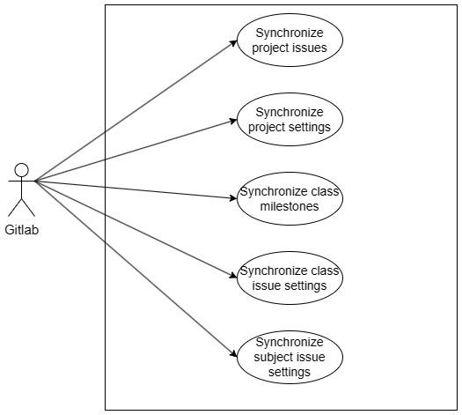

### **1.3 System Functionalities**

#### **1.3.1 Screens Flow**

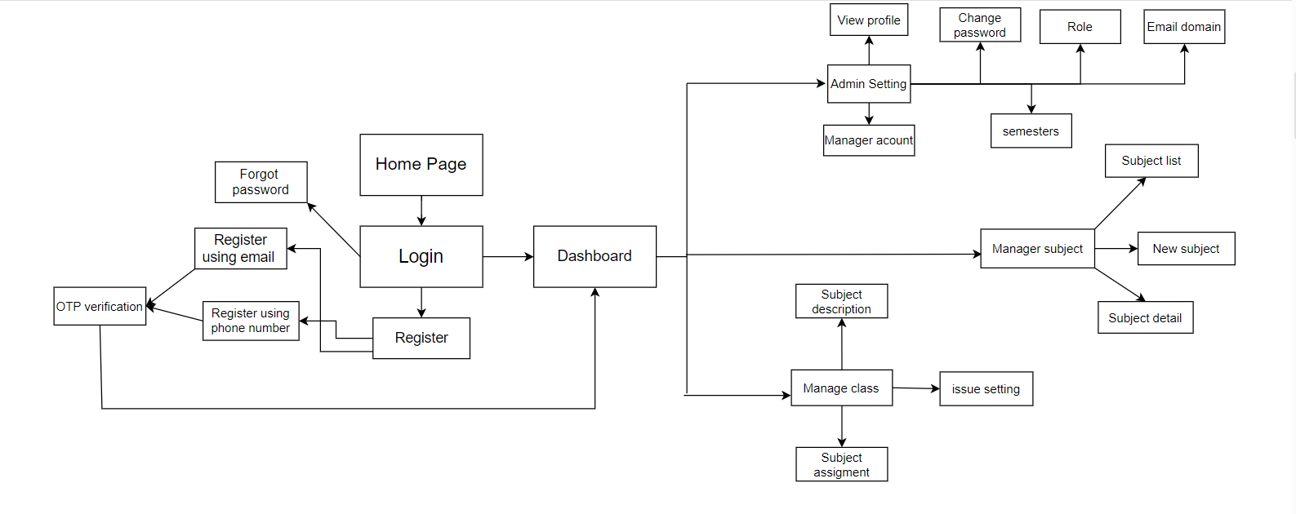

#### **1.3.2 Screen Descriptions**

*[Provide the descriptions for the screens in the Screens Flow above]*

| **#** | **Feature** | **Screen** | **Description** |
| --- | --- | --- | --- |
| 1 | Register user account | Forgot password |  |
| 2 | Register user account | Login using email |  |
| 3 | Register user account | Login using phone number |  |
| 4 | Register user account | Register |  |
| 5 | Manage subject | Subject list |  |
| 6 | Manage subject | New subject |  |
| 7 | Manage subject | Subject detail |  |
| 8 | Manage assigned subjects | subject description |  |
| 9 | Manage assigned subjects | subject assignments |  |
| 10 | Manage assigned subjects | issue settings |  |
| 11 | Manage system setting | Roles |  |
| 12 | Manage system setting | semesters |  |
| 13 | Manage system setting | permitted email domains |  |

#### **1.3.3 Screen Authorization**

| Screen | Student | Team Lead | Teacher | Manager | Admin |
| --- | --- | --- | --- | --- | --- |
| View Issues | X | X | X | X | X |
| Add Issue | X |  |  |  |  |
| Edit Issue | Own Issues | All Issues |  |  | X |
| Delete Issue |  |  |  |  | X |
| Assign Issue |  | X |  |  |  |
| Change Issue Status | Own Issues | All Issues |  |  | X |
| View Reports |  | X | X | X | X |
| Configure Workflows |  |  |  | X | X |
| Manage Issue Fields |  |  |  | X | X |
| Manage Projects |  |  | X | X | X |
| Manage Users |  |  |  |  | X |
| Manage systems setting |  |  |  |  | x |

#### **1.3.4 Non-UI Functions**

| **#** | **Feature** | **System Function** | **Description** |
| --- | --- | --- | --- |
| 1 | Issue Sync | GitLab Issue Sync | A scheduled cron job that syncs IMS issues with GitLab issues twice a day. Pulls in new GitLab issues and updates existing issue details. |
| 2 | Notifications | Email Notifications | An email service that sends issue assignment, due date, and status change notifications to relevant users. Triggered by events in IMS. |
| 3 | Notifications | SMS Notifications | An SMS service that sends reminders for upcoming issue due dates to assigned users. Triggered by events in IMS. |
| 4 | Reporting | Issue Metrics API | Provides issue statistics and metrics to the reporting dashboard via a REST API. Used to generate graphs and charts. |

#### **1.3.5 Entity Relationship Diagram**

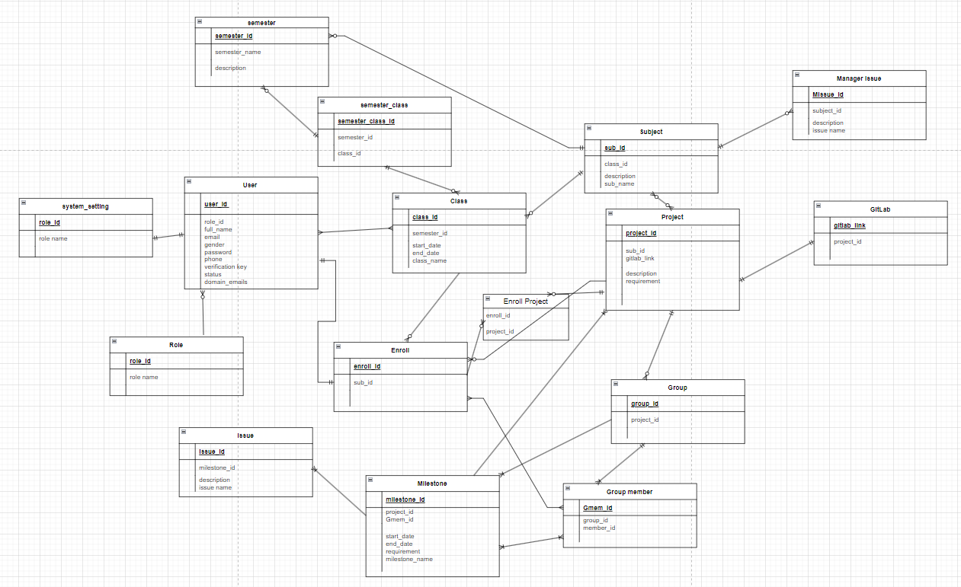

**Entities Description**

| **#** | **Entity** | **Description** |
| --- | --- | --- |
| 1 | User | Represents system users with attributes: UserID (int), FullName (string), Email (string), MobileNumber (string), Role (string), Avatar (image). |
| 2 | Project | Represents projects with attributes: ProjectID (int), ProjectName (string), Description (string). |
| 3 | Issue | Represents issues with attributes: IssueID (int), Description (string), Issue name(string) |
| 4 | Milestone | Represents milestones with attributes: MilestoneID (int), Title (string), Description (string), StartDate (date), EndDate (date) |
| 5 | Class | Represents classes with attributes: ClassID (int), ClassName (string), Status (string). |
| 6 | Subject | Represents subjects with attributes: SubjectID (int), Description (string), GitLabConfigs (string). |
| 7 | System Setting | Represents system settings with attributes: SettingID (int), Role (string), Semester (string), PermittedEmailDomains (list). |

## **2. Functional Specifications**

### **2.1 Guest Feature**

#### **2.1.1 <<UC1.1.1_Register Account>>**

##### 2.1.1.2 . Screen design

##### 2.1.1.3 . Use case

| UC ID and Name: | UC101 – Register a new Account | | |
| --- | --- | --- | --- |
| Created By: | NGUYỄN HOÀI NAM | Date Created: | 30/9/2023 |
| Primary Actor: | Guest | Secondary Actors: | None |
| Trigger: | Guest clicks on "Register" button | | |
| Description: | This use case allows an unregistered guest user to create a new user account by providing their phone number/email&password and validating it via OTP. | | |
| Preconditions: | · Guest user is not logged into the system.  · Phone number has not been registered before | | |
| Postconditions: | · New user account is created in the system.  · Entered user details are stored in the database.  · Account is set to unverified status | | |
| Normal Flow: | 1. Guest clicks "Register by Email" button.  2. Guest enters name, email, password, confirm password  3. System validates input fields  4. System creates new user account  5. System sets account status to unverified  6. System sends confirmation email to provided email | | |
| Alternative Flows: | A1:  1. Guest clicks on "Register by Phone" button  2. System prompts for name, phone number, and other details  3. Guest enters details and submits  4. System validates phone number format  5. System sends OTP to the provided phone number  6. Guest enters the received OTP  7. System validates the OTP  8. If OTP is valid, system creates new user account  9. System sets account status to unverified  10. System displays confirmation messagel | | |
| Exceptions: | E1: Database connection error during account creation.  E2: User already exists with the same phone number/email. | | |
| Priority: | High (Medium, Low), Must Have (Should Have, Could Have) ... | | |
| Frequency of Use: | Very frequent | | |
| Business Rules: | BR001 - Phone number must be unique.  BR002 - OTP is valid for 5 minutes only | | |
| Other Information: | After 3 failed OTP attempts, user must reinitiate registration.  Email notifications on successful registration are sent via SendGrid API | | |
| Assumptions: | · Users will provide accurate phone number not used before  · Guest user has internet access on phone to receive OTP.  · OTP SMS is received within 1 minute of sending.  · User will request resend OTP if not received.  · User will be able to enter OTP within 5 min validity period | | |

##### 2.1.1.3 . UI requirements

| **Field Name** | **Field Type** | **Description** |
| --- | --- | --- |
| Full Name | Text | This is for the user to input full name |
| Gender | Radio | This is for the user to choose male or female |
| Email | Text | This is for user to input valid email address for logging in |
| Password | Text | This is for user to input password address for logging in |
| Confirm password | Text | This is for the user to input confirm the password |
| Register account | Button | The user clicks to redirect to the otp code verification page for the user |
| Back to home | Hyperlink | This is the page that redirects users to home |

#### **2.1.2 . <<UC1.1.2_Guest visits site Landing Page>>**

##### 2.1.2.1 . Screen design

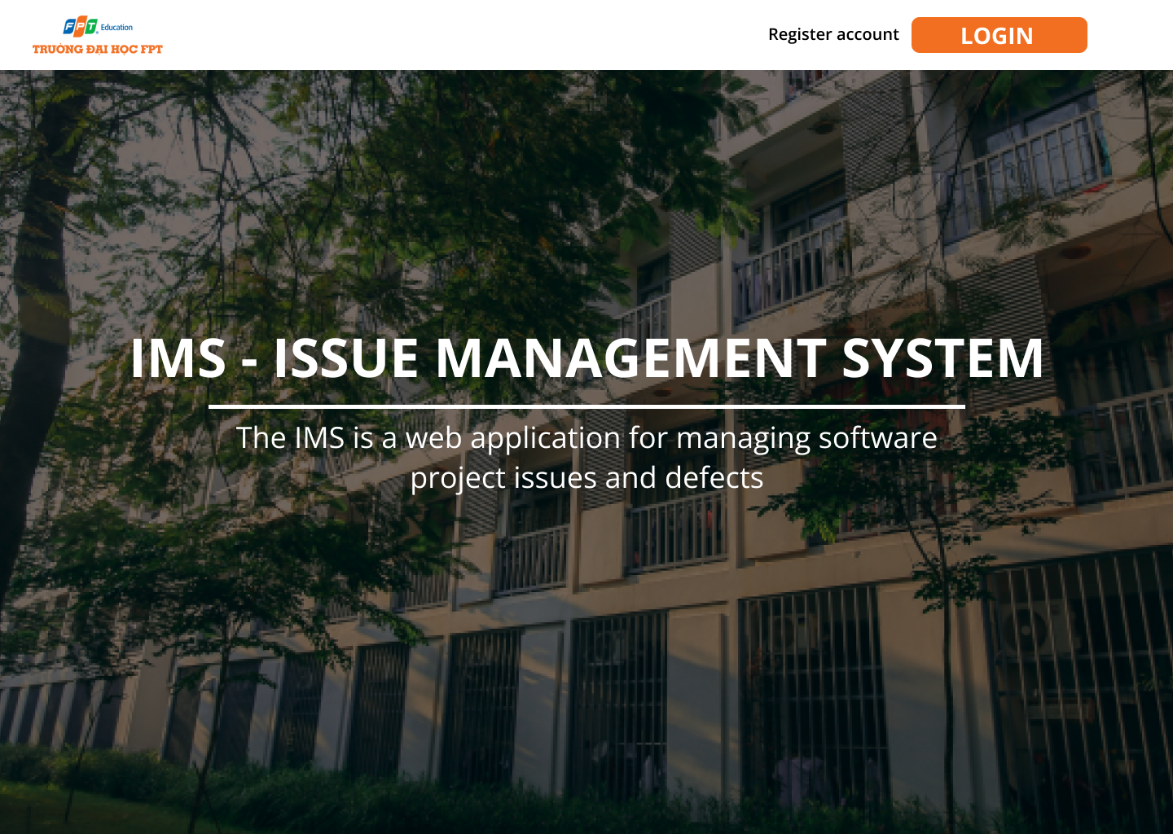

##### 2.1.2.2 . Use case

| UC ID and Name: | UC102 – Guest visits site Landing Page | | |
| --- | --- | --- | --- |
| Created By: | NGUYỄN HOÀI NAM | Date Created: | 30/9/2023 |
| Primary Actor: | Guest | Secondary Actors: | None |
| Trigger: | Guest visits site URL | | |
| Description: | This use case allows an unregistered guest user to view the Landing Page | | |
| Preconditions: | · None | | |
| Postconditions: | · Landing page is displayed | | |
| Normal Flow: | 1. Guest navigates to the site URL  2. System retrieves landing page content  3. System displays landing page introducing the system  4. Landing page contains overview, images, features list  5. Page has navigation to login and register | | |
| Alternative Flows: | None | | |
| Exceptions: | E1: Page fail. Server Error | | |
| Priority: | Very High | | |
| Frequency of Use: | Very frequent | | |
| Business Rules: | BR003: Landing page is public | | |
| Other Information: |  | | |
| Assumptions: | · Guest users visit Landing Page | | |

**Business Rules**

<<Provide the business rules those are applied only to the use case>>

| **ID** | **Business Rule** | **Business Rule Description** |
| --- | --- | --- |
| BR001 | Unique Phone Number | The phone number provided for registration must not already exist in the system for another user. |
| BR002 | OTP Expiry | The OTP sent during phone registration is valid for only 5 minutes. |
| BR003 | Unique Email | The email address provided for registration must not already exist in the system. |
| BR004 | Password Complexity | Password set during email registration must meet length, character complexity criteria. |

### **2.2 Admin Feature**

#### **2.2.1 UC1.2_View System Settings**

| UC ID and Name: | UC-201_View System Settings | | |
| --- | --- | --- | --- |
| Created By: | NGUYỄN HOÀI NAM | Date Created: | 30/09/2023 |
| Primary Actor: | Admin | Secondary Actors: | None |
| Trigger: | Admin selects "System Settings" menu option | | |
| Description: | *This use case allows the admin to view the current system settings and configurations.* | | |
| Preconditions: | Admin user is logged in | | |
| Postconditions: | System settings are displayed to admin | | |
| Normal Flow | 1. Admin clicks on "System Settings" menu option.  2. System retrieves current settings from database.  3. System displays settings to admin in readable format.  4. Settings include permitted email domains, user roles, semesters etc.  5. Admin views and verifies displayed system settings | | |
| Alternative Flows: | ***None*** | | |
| Exceptions: | E1: System settings not found in the database. | | |
| Priority: | Medium | | |
| Frequency of Use: | Frequent | | |
| Business Rules: | BR201 - Admin can view settings anytime | | |
| Other Information: | None | | |
| Assumptions: | Settings are stored accurately in backend database | | |

#### **2.2.2** **UC1.2 _ Update Permitted Email Domains**

##### **2.2.2.1 Screen design**

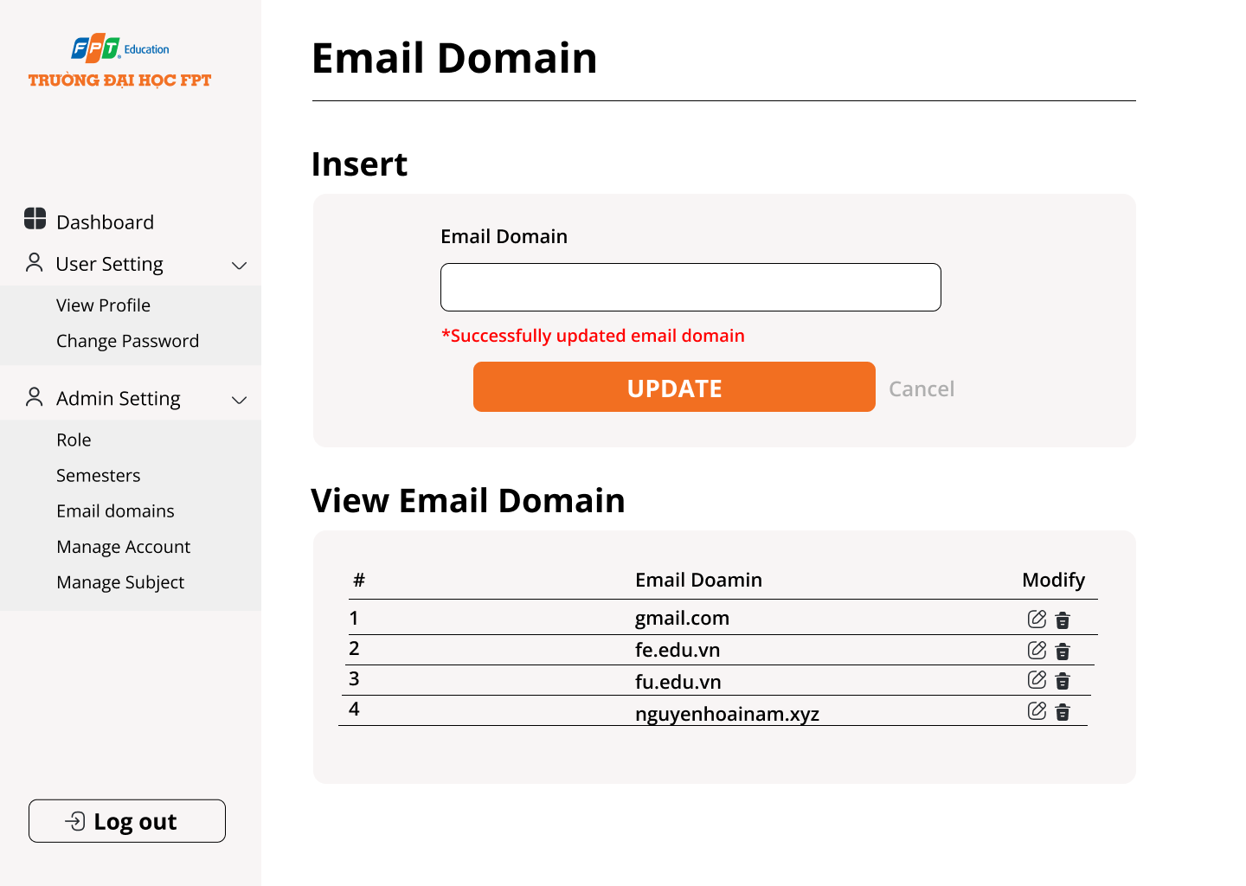

##### **2.2.2.2 Use case**

| UC ID and Name: | UC-202_ Update Permitted Email Domains | | |
| --- | --- | --- | --- |
| Created By: | NGUYỄN HOÀI NAM | Date Created: | 30/09/2023 |
| Primary Actor: | Admin | Secondary Actors: | None |
| Trigger: | Admin selects "Manage Email Domains" option.  Scheduled cron job to sync email domains runs | | |
| Description: | *This use case allows the admin to view the permitted email domains list and update it by adding or removing domain names.* | | |
| Preconditions: | Admin user is logged in | | |
| Postconditions: | Email domains list is updated | | |
| Normal Flow | 1. Admin navigates to Manage Email Domains screen.  2. System retrieves and displays the permitted email domains list.  3. Admin clicks "Add Domain" button.  4. Admin enters new domain name (e.g., xyzcompany.com)  5. Admin clicks "Save Changes”.  6. System validates new domain name.  7. System updates permitted email domains list.  8. System displays updated domains list | | |
| Alternative Flows: | A1: Remove Email Domain  1. Admin selects a domain and clicks "Remove”.  2. System updates domains list | | |
| Exceptions: | E1: Database error during update. | | |
| Priority: | Medium | | |
| Frequency of Use: | Infrequent | | |
| Business Rules: | BR202 - Email domains must be valid format | | |
| Other Information: | None | | |
| Assumptions: |  | | |

##### **2.2.2.3 UI requirements**

| **Field Name** | **Field Type** | **Description** |
| --- | --- | --- |
| Email domain | Button | This is for the user to input email domain |
| Update | Button | The user clicks and will update the semester into the database |
| Cancel | Hyperlink | This is the page that redirects users to reload that page |
| Icon edit modify | Hyperlink | This is the page that redirects to the modal to modify the semester |
| Icon delete modify | Hyperlink | This is the page that redirects to the modal for users to confirm delete the semester |

#### **2.2.4.1 UC204 - Configure Semester Details**

##### **2.2.4.1 Screen design**

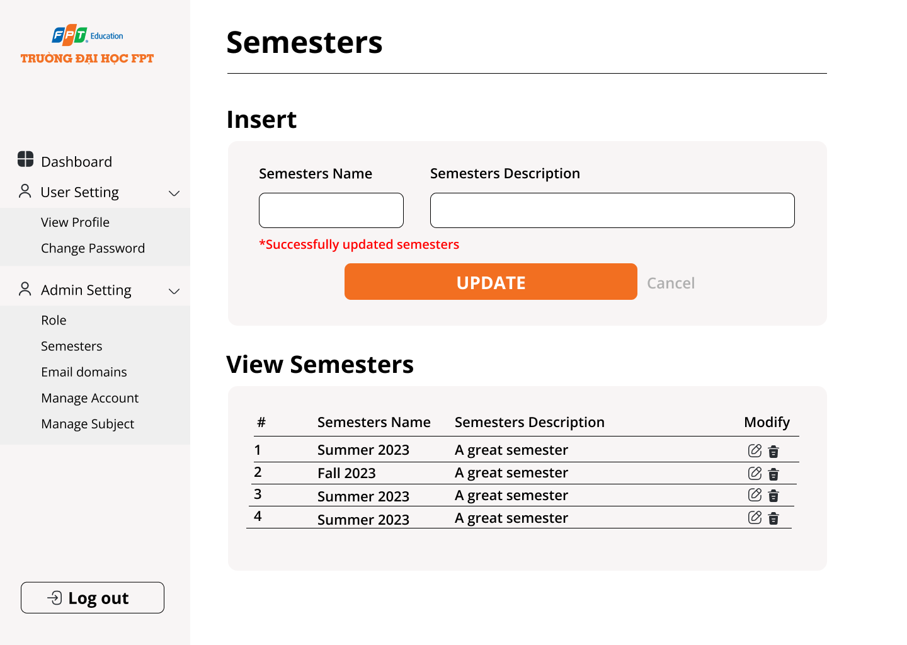

##### **2.2.4.2 Use case**

| UC ID and Name: | **UC204 - Configure Semester Details** | | |
| --- | --- | --- | --- |
| Created By: | Nguyễn Hoài Nam | Date Created: | 25/10/2023 |
| Primary Actor: | Admin | Secondary Actors: | None |
| Trigger: | Admin selects "Manage Semesters" menu option | | |
| Description: | *This use case allows the admin to configure academic semester details like start date, end date etc.* | | |
| Preconditions: | Admin user is logged in | | |
| Postconditions: | Semester details are configured | | |
| Normal Flow | 1. Admin selects "Manage Semesters" option  2. System displays list of existing semesters  3. Admin clicks "Add Semester" button  4. Admin enters semester details:  5. Name  6. Start date  7. End date  8. Active status  9. Admin clicks "Save" to add new semester  10. To edit a semester, Admin selects it and clicks "Edit"  11. Admin updates details and saves | | |
| Alternative Flows: | A1: Import semesters from CSV | | |
| Exceptions: | E1: Invalid data  1. System shows error  2. Admin corrects and re-saves | | |
| Priority: | Medium | | |
| Frequency of Use: | Infrequent | | |
| Business Rules: | BR205: Semester name must be unique  BR206: Start date must be before end date | | |
| Other Information: | None | | |
| Assumptions: |  | | |

##### **2.2.4.3 Ui requirements**

| **Field Name** | **Field Type** | **Description** |
| --- | --- | --- |
| Semesters Name | Button | This is for the user to input semesters name |
| Semesters Description | Text | This is for the user to input semesters description |
| Update | Button | The user clicks and will update the semester into the database |
| Cancel | Hyperlink | This is the page that redirects users to reload that page |
| Icon edit modify | Hyperlink | This is the page that redirects to the modal to modify the semester |
| Icon delete modify | Hyperlink | This is the page that redirects to the modal for users to confirm delete the semester |

2.2.5 UC211_Admin Adds New Subject

2.2.5.1 **Screen design**

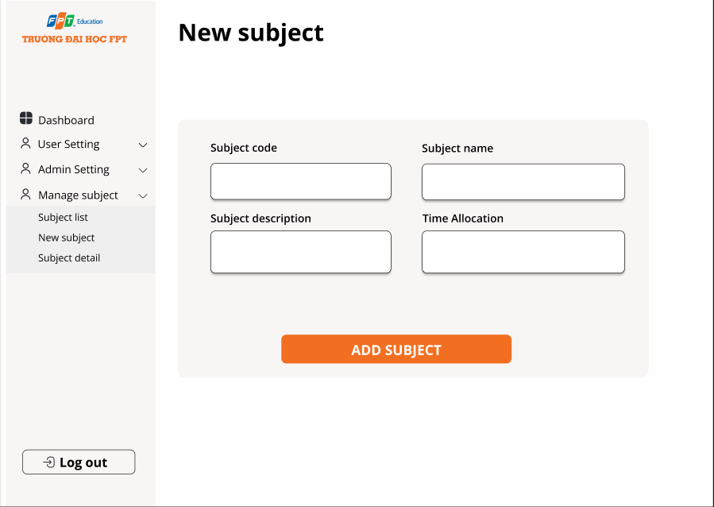

2.2.5.2 Use case

| UC ID and Name: | UC211_Admin Adds New Subject | | |
| --- | --- | --- | --- |
| Created By: | Đặng Việt Anh | Date Created: | 30/09/2023 |
| Primary Actor: | Admin | Secondary Actors: | None |
| Trigger: | Admin clicks "Add New Subject" button | | |
| Description: | *This use case allows the admin to add new subjects* | | |
| Preconditions: | Admin user is logged in | | |
| Postconditions: | New subject is added to system | | |
| Normal Flow | 1. Admin clicks "Add New Subject" button  2. System displays subject creation form  3. Admin enters details like name, code, description, status  4. Admin clicks "Create Subject" button  5. System validates input data  6. System adds new subject record in database  7. System displays confirmation message | | |
| Alternative Flows: | None | | |
| Exceptions: | E1: Invalid input data  1. System displays error message  2. Admin corrects data and re-submits | | |
| Priority: | Medium | | |
| Frequency of Use: | Infrequent | | |
| Business Rules: | BR207: Subject code must be unique  BR208: Subject name cannot be blank | | |
| Other Information: | None | | |
| Assumptions: |  | | |

2.2.5.3 **UI Requirements**

| **Field Name** | **Field Type** | **Description** |
| --- | --- | --- |
| Subject code | Text | This is used to enter the subject code |
| Subject name | Text | This is used to enter the subject name |
| Subject description | Text | This is used to enter the subject description |
| Time allocation | Text | This is used to enter the course duration |
| Add subject | Button | The user clicks and will add a subject |

2.2.6 UC212 - Admin Updates Subject

2.2.6.1 Screen design

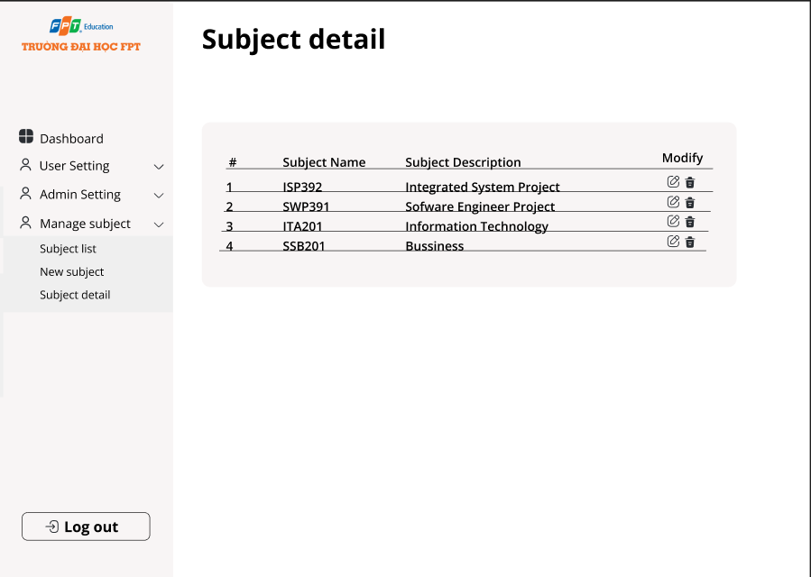

2.2.6.2 Use case

| UC ID and Name: | UC212 - Admin Updates Subject | | |
| --- | --- | --- | --- |
| Created By: | Đặng Việt Anh | Date Created: | 30/09/2023 |
| Primary Actor: | Admin | Secondary Actors: | None |
| Trigger: | Admin selects "Edit" button for a subject | | |
| Description: | *This use case allows the admin to update subjects* | | |
| Preconditions: | · Admin is logged in  · Subject exists in system | | |
| Postconditions: | Subject details are updated | | |
| Normal Flow | 1. Admin navigates to the Manage Subjects screen  2. System displays list of existing subjects  3. Admin selects a subject and clicks "Edit" button  4. System displays subject edit form with current details populated  5. Admin modifies details like description, status, etc.  6. Admin clicks "Save Changes" button  7. System validates updated data  8. System updates subject details in database  9. System displays confirmation message | | |
| Alternative Flows: | None | | |
| Exceptions: | E1: Invalid input data  3. System displays error message  4. Admin corrects data and re-submits | | |
| Priority: | Medium | | |
| Frequency of Use: | Infrequent | | |
| Business Rules: | BR209: Subject code cannot be changed | | |
| Other Information: | None | | |
| Assumptions: |  | | |

2.2.6.3 **UI Requirements**

| **Field Name** | **Field Type** | **Description** |
| --- | --- | --- |
| Icon edit modify | Hyperlink | This is the page that redirects to the modal to modify the subject |
| Icon delete modify | Hyperlink | This is the page that redirects to the modal for users to confirm delete the subject |

### **2.3 Manager Feature**

#### **2.3.1 UC301 - Manager Views Assigned Subjects**

2.3.1.1 Screen design

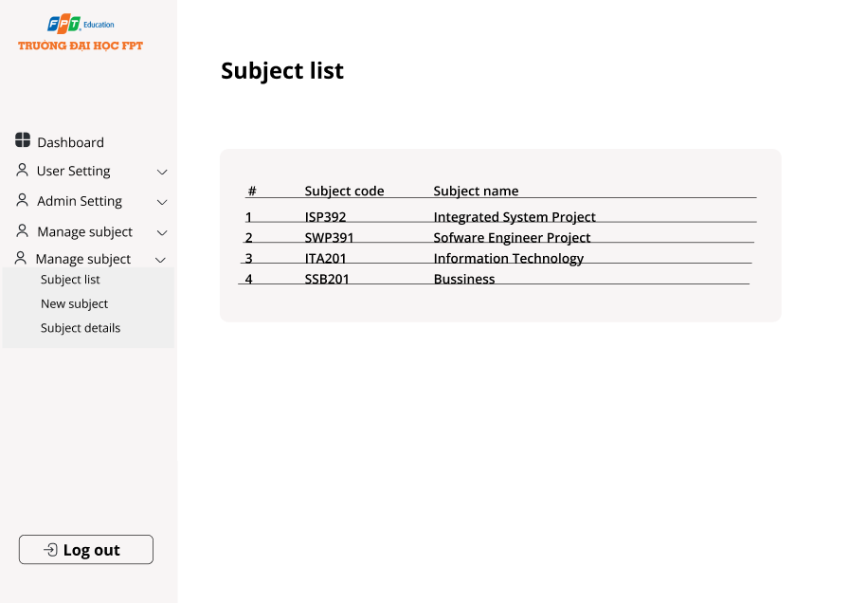

2.3.1.2 Use case

| ID and Name: | **UC301 - Manager Views Assigned Subjects** | | |
| --- | --- | --- | --- |
| Created By: | Đặng Việt Anh | Date Created: | 30/09/2023 |
| Primary Actor: | Manager | Secondary Actors: |  |
| Description: | Manager Views Assigned Subjects assigned to students. | | |
| Trigger: | Manager selects "My Subjects" option | | |
| Preconditions: | Manager is logged in | | |
| Postconditions: | List of assigned subjects is displayed | | |
| Normal Flow: | 1. Manager selects "My Subjects" menu option  2. System retrieves list of subjects assigned to manager  3. System displays list of subject names and codes  4. Manager reviews the list of assigned subjects | | |
| Alternative Flows: | None | | |
| Exceptions: | E1: Error retrieving subjects  System displays error message | | |
| Priority: | High | | |
| Frequency of Use: | Frequency | | |
| Business Rules: | BR301: Manager can only view assigned subjects | | |
| Other Information: |  | | |
| Assumptions: | Subject assignment data is accurate | | |

#### **2.3.2 UC302 - Manager Updates Subject Description**

2.3.2.1 Screen design

#### 

2.3.2.2 Use case

| ID and Name: | **UC302 - Manager Updates Subject Description** | | |
| --- | --- | --- | --- |
| Created By: | Đặng Việt Anh | Date Created: | 30/09/2023 |
| Primary Actor: | Manager | Secondary Actors: |  |
| Description: | Allow Manager Updates Subject Description | | |
| Trigger: | Manager selects "Edit" option for a subject | | |
| Preconditions: | · Manager is logged in  · Subject is assigned to manager | | |
| Postconditions: | · Subject description is updated | | |
| Normal Flow: | 1. Manager navigates to the assigned subjects list  2. Manager selects a subject and clicks "Edit"  3. System displays subject edit form  4. Manager modifies the subject description  5. Manager clicks "Save Changes"  6. System validates the updated description  7. System updates subject description in database  8. System displays confirmation message | | |
| Alternative Flows: | 5.1 If don’t click save then click close button sceen will display “Changes have not been saved, are you sure you want to exit?” | | |
| Exceptions: | E1: Invalid description  1. System displays error  2. Manager corrects and resubmits | | |
| Priority: | High | | |
| Business Rules: | BR302: Manager can only edit description | | |
| Other Information: |  | | |

**2.3.2.3 UI Requirements**

| **Field Name** | **Field Type** | **Description** |
| --- | --- | --- |
| Icon edit modify | Hyperlink | This is the page that redirects to the modal to modify the subject |
| Icon delete modify | Hyperlink | This is the page that redirects to the modal for users to confirm delete the subject |

2.3.3 UC303 - Manager Adds New Class

2.3.3.1 Screen design

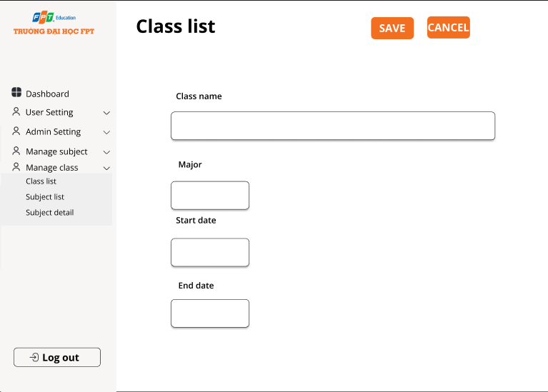

2.3.3.2 Use case Specification

| ID and Name: | UC303 - Manager Add New Class | | |
| --- | --- | --- | --- |
| Created By: | VŨ QUỐC BÌNH | Date Created: | 30/09/2023 |
| Primary Actor: | Manager | Secondary Actors: |  |
| Description: | Allow Manager to add new class to the system | | |
| Trigger: | Manager clicks "NEW" button in Class list option | | |
| Preconditions: | · Manager is logged in | | |
| Postconditions: | · New class is added to system | | |
| Normal Flow: | 1. Manager clicks "NEW" button  2. System displays class creation form  3. Manager enters details like name, major, start date, end date  4. Manager clicks "SAVE" button  5. System validates input data  6. System adds new class record in database  7. System displays confirmation message | | |
| Alternative Flows: | 4.1 If don’t click SAVE button then click close button screen will display “Changes have not been saved, are you sure you want to exit?” | | |
| Exceptions: | E1: Invalid description  3. System displays error  4. Manager corrects and resubmits | | |
| Priority: | High | | |
| Business Rules: | BR303: Class code must be unique  BR304: Class name cannot be blank | | |
| Other Information: |  | | |

2.3.4 UC303 _Manager Updates Class

2.3.4.1 Screen design



2.3.4.2 Use case Specification

| ID and Name: | UC303 - Manager Adds New Class | | |
| --- | --- | --- | --- |
| Created By: | VŨ QUỐC BÌNH | Date Created: | 30/09/2023 |
| Primary Actor: | Manager | Secondary Actors: |  |
| Description: | Allow Manager to update class details | | |
| Trigger: | Manager selects "Edit" button for a class | | |
| Preconditions: | · Manager is logged in  · Class exists in system | | |
| Postconditions: | · Class details are updated | | |
| Normal Flow: | 1. Manager navigates to Manage Classes screen  2. System displays list of existing classes  3. Manager selects a class and clicks "Edit" button  4. System displays class edit form with current details populated  5. Manager modifies details like status, semester etc.  6. Manager clicks "SAVE" button  7. System validates updated data  8. System updates class details in database  9. System displays confirmation message | | |
| Alternative Flows: | 6.1 If don’t click the save button then clicking the close button screen will display “Changes have not been saved, are you sure you want to exit?” | | |
| Exceptions: | E1: Invalid data  · System displays error  · Manager corrects data and re-submits | | |
| Priority: | High | | |
| Business Rules: | BR305: Class code cannot be changed | | |
| Other Information: |  | | |

### **2.4 Manage classes**

2.4.1 UC401 - Teacher/Manager Views Assigned Classes

2.4.1.1 Screen design

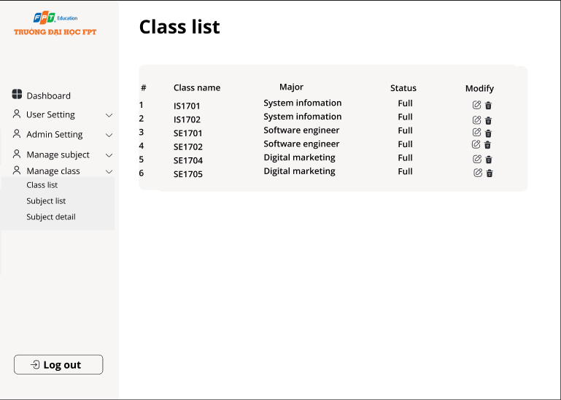  
  
2.4.1.2 Use case Specification

| ID and Name: | UC401 - Teacher Views Assigned Classes | | |
| --- | --- | --- | --- |
| Created By: | VŨ QUỐC BÌNH | Date Created: | 30/09/2023 |
| Primary Actor: | Teacher/Manager | Secondary Actors: |  |
| Description: | Teacher views list of classes assigned to them | | |
| Trigger: | Teacher selects "Class list" option | | |
| Preconditions: | · Teacher/Manager is logged in | | |
| Postconditions: | · List of assigned classes is displayed | | |
| Normal Flow: | 1. Teacher/Manager selects "Class list" menu option  2. System retrieves list of classes assigned to the teacher/manager  3. System displays list of class names information of classes | | |
| Alternative Flows: | None | | |
| Exceptions: | None | | |
| Priority: | High | | |
| Business Rules: | BR401: Teacher/Manager can only view assigned classes | | |
| Other Information: |  | | |
| Assumption | Class assignment data is accurate | | |

2.4.2 UC402 - Teacher Updates Class Details  
2.4.2.1 Screen design

  
2.4.2.2Use case Specification

| ID and Name: | UC402 - Teacher Updates Class Details | | |
| --- | --- | --- | --- |
| Created By: | VŨ QUỐC BÌNH | Date Created: | 30/09/2023 |
| Primary Actor: | Teacher | Secondary Actors: |  |
| Description: | Teacher selects "Edit" button for a class | | |
| Trigger: | Teacher/Manager selects "Class list" option | | |
| Preconditions: | · Teacher is logged in  · Class is assigned to teacher | | |
| Postconditions: | · Permitted class details are updated | | |
| Normal Flow: | 1. Teacher navigates to the assigned classes list  2. Teacher selects a class and clicks "Edit" icon button  3. System displays class edit form  4. Teacher modifies allowed details like status, description etc.  5. Teacher clicks "Save "  6. System validates updated data  7. System updates details in database  8. System displays confirmation message | | |
| Alternative Flows: | 5.1 If don’t click the save button then clicking the close button screen will display “Changes have not been saved, are you sure you want to exit?” | | |
| Exceptions: | E1: Invalid data  1. System displays error  2. Teacher corrects and resubmits | | |
| Priority: | High | | |
| Business Rules: | BR402: Teacher/Manager can only edit permitted details | | |
| Other Information: |  | | |
| Assumption | Class assignment data is accurate | | |

## **3. UI Requirements**

### **3.1 Landing page**

This screen show landing page show information landing page

**Related use cases:**

· UC1.1_Register account

**Prototype/Mockup**



**UI Requirements**

| **Field Name** | **Field Type** | **Description** |
| --- | --- | --- |
| Login | Button | User clicks to authenticate him/herself into the system with provided email & password |
| Register account | Button | User clicks to redirect to the User Register page for registering new user account to access the system |

### **3.2 Register account**

This screen allows users to create email/phone accounts into the system

**Related use cases:**

· UC1.1_Register account

#### 3.2.1 Choose register account

**Prototype/Mockup**

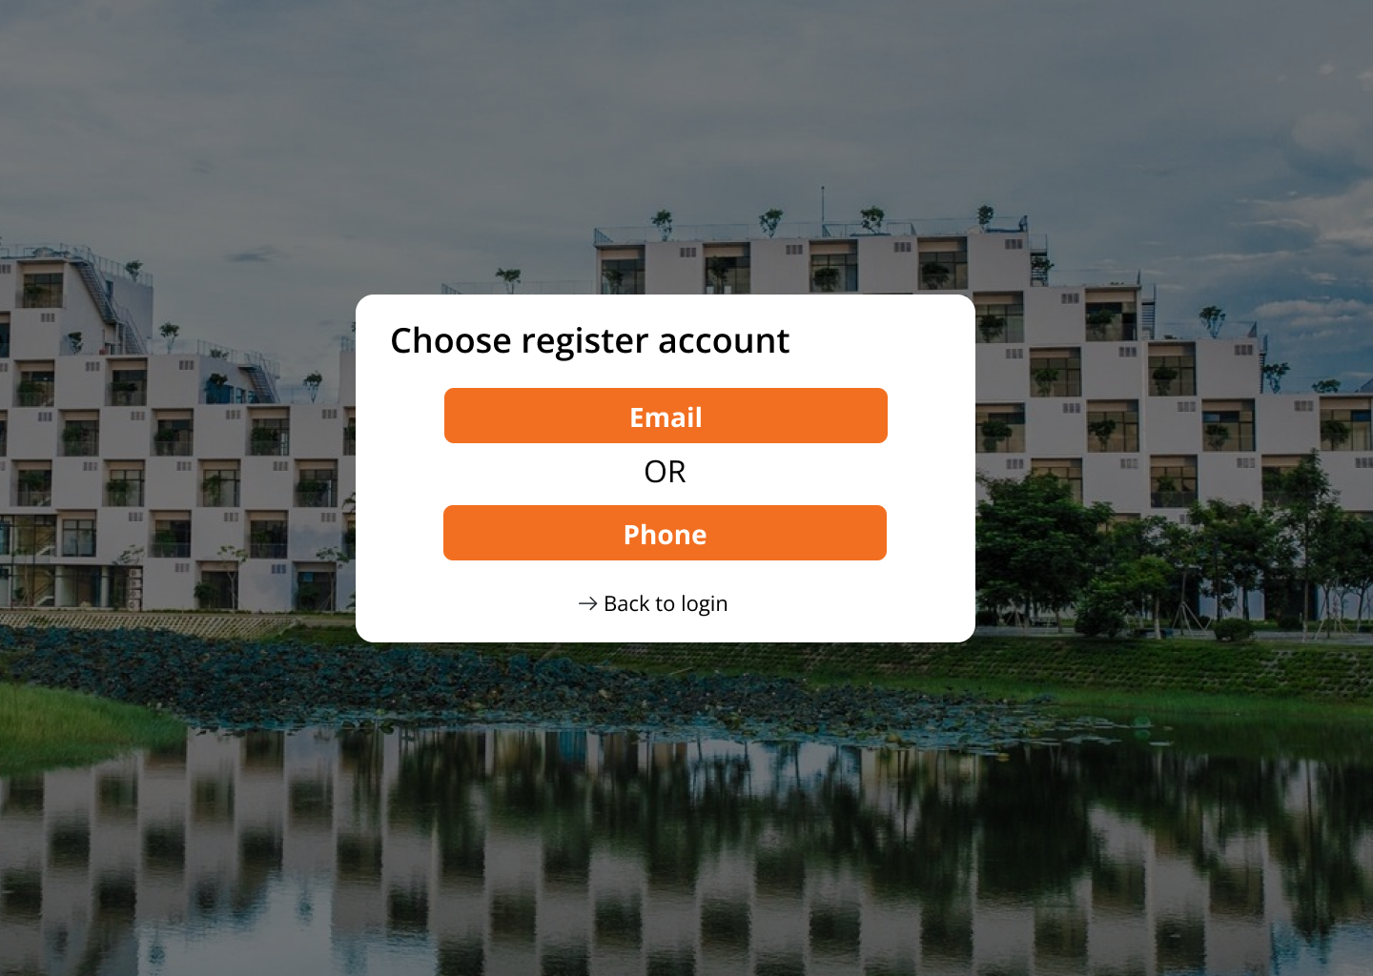

**UI Requirements**

| **Field Name** | **Field Type** | **Description** |
| --- | --- | --- |
| Register account by email | Button | The user clicks to redirect to the User Registration page to register a new user account using the system access email |
| Register account by phone | Button | The user clicks to redirect to the User Registration page to register a new user account using the system access phone |

#### 3.2.2 Register account by email

**Prototype/Mockup**

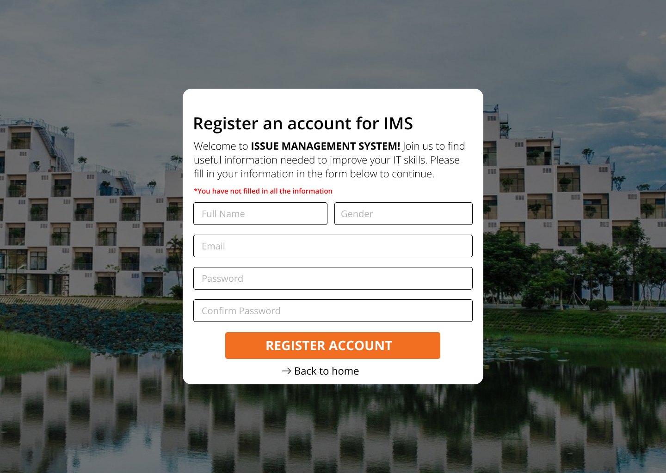

**UI Requirements**

| **Field Name** | **Field Type** | **Description** |
| --- | --- | --- |
| Full Name | Text | This is for the user to input full name |
| Gender | Radio | This is for the user to choose male or female |
| Email | Text | This is for user to input valid email address for logging in |
| Password | Text | This is for user to input password address for logging in |
| Confirm password | Text | This is for the user to input confirm the password |
| Register account | Button | The user clicks to redirect to the otp code verification page for the user |
| Back to home | Hyperlink | This is the page that redirects users to home |

#### 3.2.3 Register account by phone

**Prototype/Mockup**

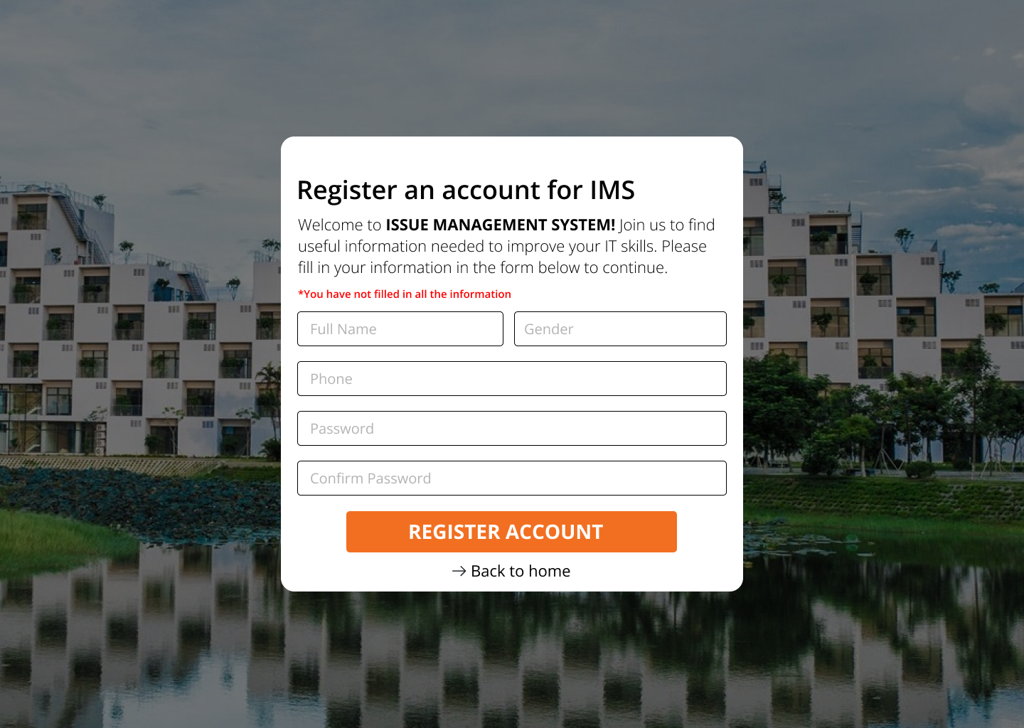

**UI Requirements**

| **Field Name** | **Field Type** | **Description** |
| --- | --- | --- |
| Full Name | Text | This is for the user to input full name |
| Gender | Radio | This is for the user to choose male or female |
| Phone | Text | This is for user to input valid phone for logging in |
| Password | Text | This is for user to input password address for logging in |
| Confirm password | Text | This is for the user to input confirm the password |
| Register account | Button | The user clicks to redirect to the otp code verification page for the user |
| Back to home | Hyperlink | This is the page that redirects users to home |

#### 3.2.4 Verify Account

**Prototype/Mockup**

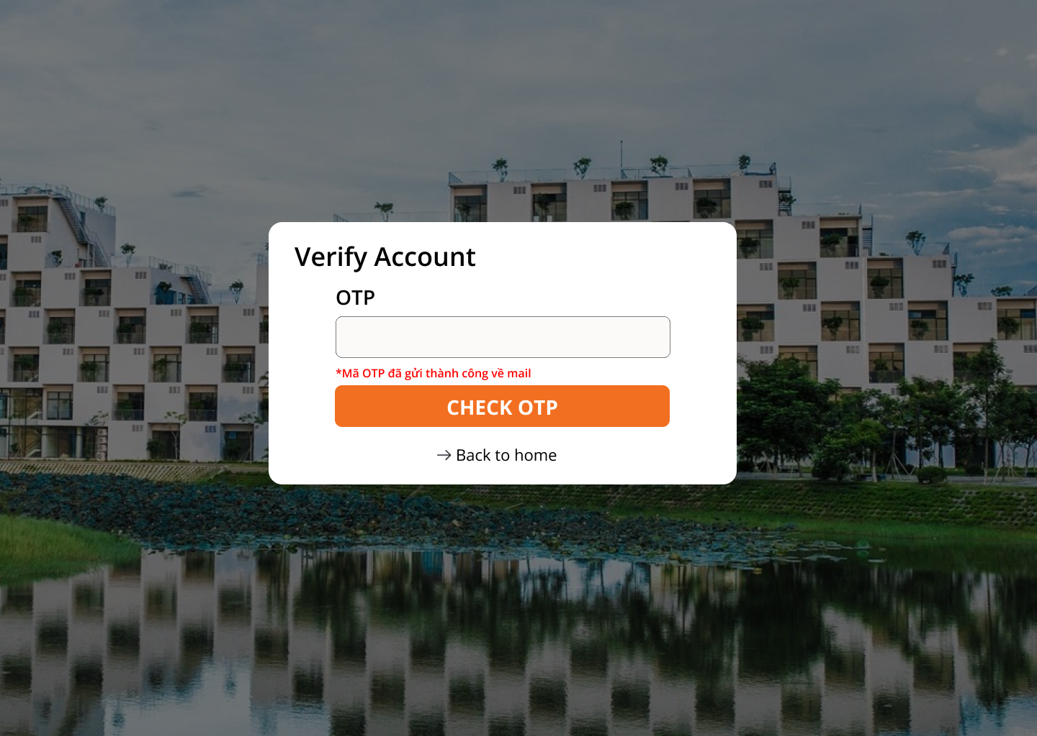

**UI Requirements**

| **Field Name** | **Field Type** | **Description** |
| --- | --- | --- |
| OTP | text | This is for the user to input otp email / phone |
| Check OTP | Button | The user clicks to redirect to the home page after checking validation |
| Back to home | Hyperlink | This is the page that redirects users to home |

### **3.3 Login account**

This screen allows user to be authenticated to the system screens/functionalities

**Prototype/Mockup**

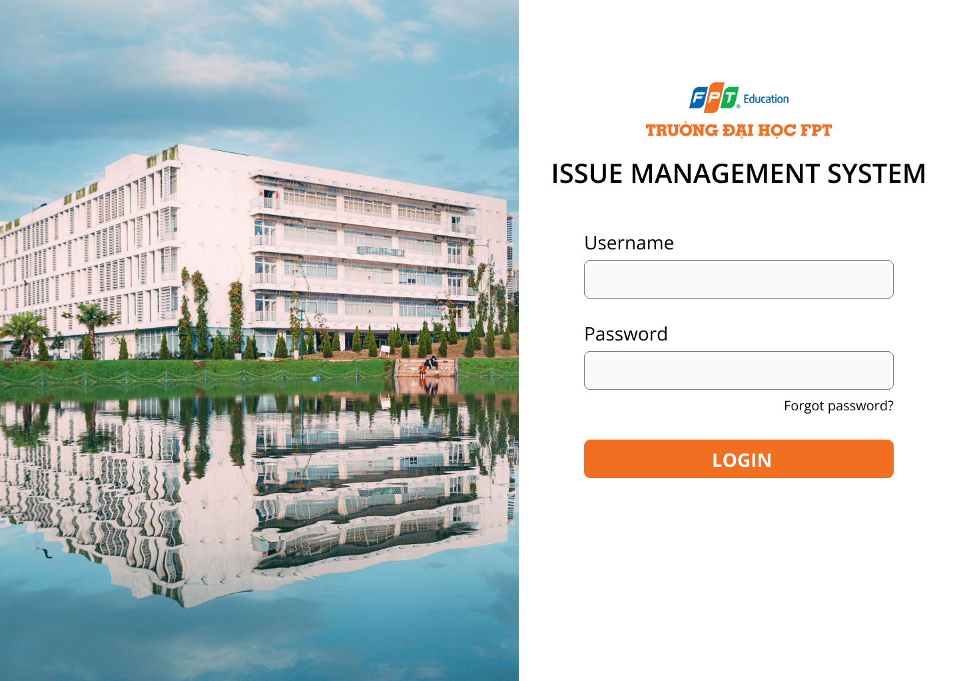

**UI Requirements**

| **Field Name** | **Field Type** | **Description** |
| --- | --- | --- |
| Username | Text | This is for user to input valid email address/ phone for logging in |
| Password | Text | This is for user to input password for logging in |
| Login | Button | User clicks to authenticate him/herself into the system with provided email/phone & password |

### **3.4 Manage system settings**

This screen shows modified roles, terms, and permitted email domains

**Related use cases:**

·  UC2.2_Admin Feature

#### 3.4.1 Semesters

**Prototype/Mockup**



**UI Requirements**

| **Field Name** | **Field Type** | **Description** |
| --- | --- | --- |
| Semesters Name | Button | This is for the user to input semesters name |
| Semesters Description | Text | This is for the user to input semesters description |
| Update | Button | The user clicks and will update the semester into the database |
| Cancel | Hyperlink | This is the page that redirects users to reload that page |
| Icon edit modify | Hyperlink | This is the page that redirects to the modal to modify the semester |
| Icon delete modify | Hyperlink | This is the page that redirects to the modal for users to confirm delete the semester |

#### 3.4.2 Role

**Prototype/Mockup**

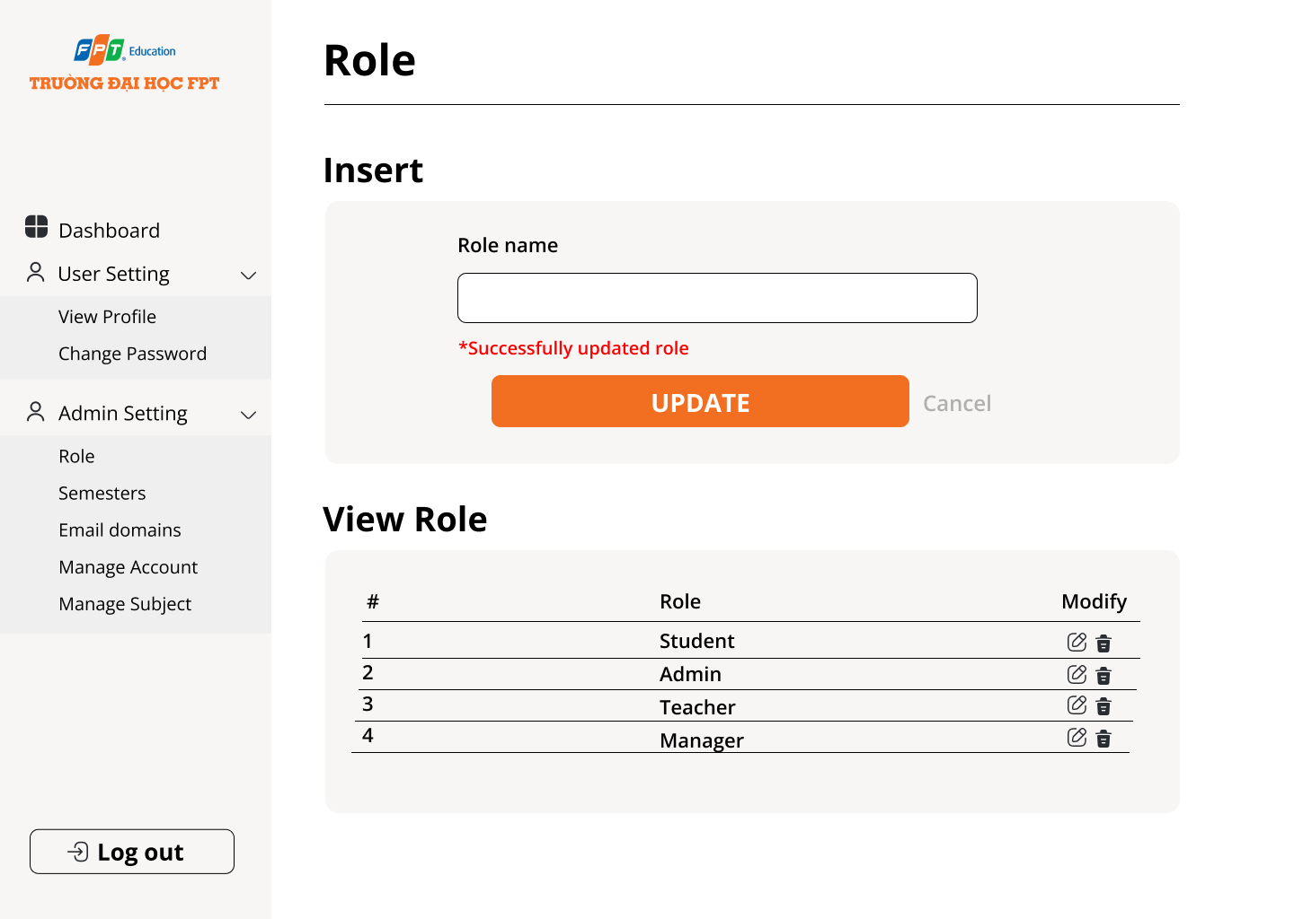

**UI Requirements**

| **Field Name** | **Field Type** | **Description** |
| --- | --- | --- |
| Role Name | Button | This is for the user to input role name |
| Update | Button | The user clicks and will update the semester into the database |
| Cancel | Hyperlink | This is the page that redirects users to reload that page |
| Icon edit modify | Hyperlink | This is the page that redirects to the modal to modify the semester |
| Icon delete modify | Hyperlink | This is the page that redirects to the modal for users to confirm delete the semester |

#### 3.4.3 Email domain

**Prototype/Mockup**



**UI Requirements**

| **Field Name** | **Field Type** | **Description** |
| --- | --- | --- |
| Email domain | Button | This is for the user to input email domain |
| Update | Button | The user clicks and will update the semester into the database |
| Cancel | Hyperlink | This is the page that redirects users to reload that page |
| Icon edit modify | Hyperlink | This is the page that redirects to the modal to modify the semester |
| Icon delete modify | Hyperlink | This is the page that redirects to the modal for users to confirm delete the semester |

### **3.4 Manage subject**

This screen allows the admin to view the list of subjects, add new and update details.

**Related use cases:**

UC2.2_Admin Feature

#### 3.4.1 Subject list



#### 

#### 

#### 

#### 

#### 

#### 

#### 3.4.2 New subject



**UI Requirements**

| **Field Name** | **Field Type** | **Description** |
| --- | --- | --- |
| Subject code | Text | This is used to enter the subject code |
| Subject name | Text | This is used to enter the subject name |
| Subject description | Text | This is used to enter the subject description |
| Time allocation | Text | This is used to enter the course duration |
| Add subject | Button | The user clicks and will add a subject |

#### 3.4.3 Subject details



**UI Requirements**

| **Field Name** | **Field Type** | **Description** |
| --- | --- | --- |
| Icon edit modify | Hyperlink | This is the page that redirects to the modal to modify the subject |
| Icon delete modify | Hyperlink | This is the page that redirects to the modal for users to confirm delete the subject |